We will be making necessary repairs to the Beach Boardwalk this week,
We anticipate closure of the beach boardwalk Wednesday 2/13 and Thursday 2/14
Please use the public boardwalk to the north of Beacher’s Lodge
Find access to public ramp between Lobby and Conference room
Pool area will not be affected and will remain open 8am - Dusk
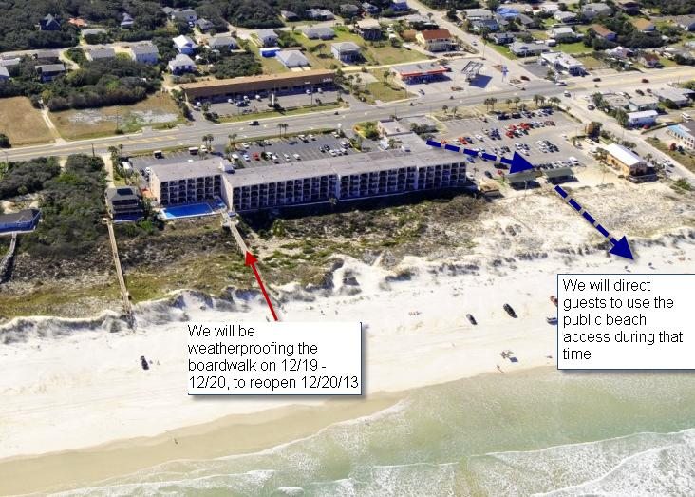
Please use public board walk to get to beach on Wednesday and Thursday.
We will be closing the boardwalk on Wednesday and possibly Thursday, 2/13 and 2/14. Use the public beach access between conference room and office on these days.

